You are to find sites that exemplify the following color schemes:

* Monochromatic

Bird Malaysia

bird-malaysia.com/

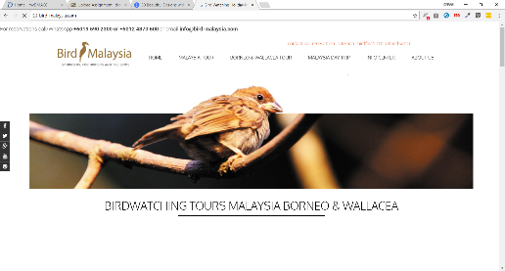

* Analogous

Bigtop

bigtop.jobs/jobs/



* Split Complimentary

Paper Tiger

https://www.papertiger.com/

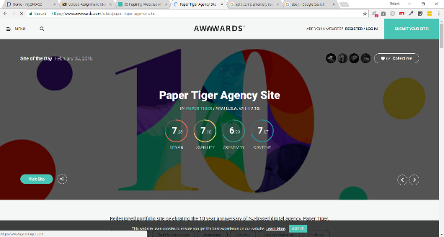

Find one site for each of the above. Take a screen shot of that site. Place the screen shot in a Microsoft Word document and identify the color scheme. Copy and paste the URL to the site above or below the screen shot.   *You MUST use an actual live site --  not just a picture of one used from another source.*

*Do not use any of the examples discussed in class. You must find different examples. (click on the PDF to view the sites discussed in class - you cannot use these for this assignment).*

You may use Adobe Kuler to assist you in the identification. Also discuss how the color intensity affects the overall look. Are the colors intense or muted. Discuss the use of neutrals - black, gray and white in the design. How do the neutrals effect the color scheme?